**Mobile Programming-ICP9**

**Name: Vishnumonish Kankanala**

**Email:** [**VKM5P@umsystem.edu**](mailto:VKM5P@umsystem.edu)

**Github link:** [**https://github.com/Vishnumonish/web-development/tree/main/ICP_9**](https://github.com/Vishnumonish/web-development/tree/main/ICP_9)

**Partner name: RajendraKumar Ganji**

**Partner email:** [**RGN42@umsystem.edu**](mailto:RGN42@umsystem.edu)

**Partner github link:** [**https://github.com/Rajendraganji/WebCourse2022/tree/main/WebPart/ICP9**](https://github.com/Rajendraganji/WebCourse2022/tree/main/WebPart/ICP9)

1.The main goal of ICP9 is to develop food ordering applications for Android.

2.In this particular ICP , We have a small Pizza delivery App. By using this a customer can order Pizza online.

3.He can choose the size and additional add-ons which he wants.

4.Once he places the order, a confirmation mail with order details will be sent to customer.

5.He can also check the summy of his order by clicking on summary option.

1)Added checkboxes for size of Pizza, what toppings to choose, meat options with a submit button to display on the frontend of the application (to the User) also added a textfield to input the name of the user on their order.

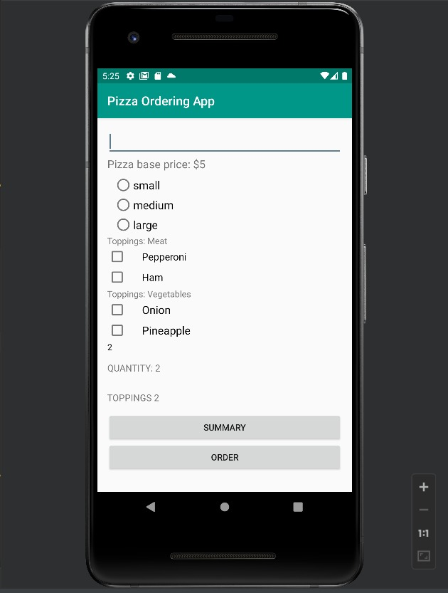

2) Using the checkboxes we have implemented, the user when chooses 2 toppings, it is shown as below.

3) Here, as we can see in the image below, we had added the “**order**” and “**summary**” buttons for the user to make the order after choosing the pizza size and toppings .

4) User gets to see the summary in the listview as shown in the below format upon clicking the Summary Button on the application.

5)we have Created the “**go to order**” button, which navigates back to the order screen when the user clicks on this button, by which the user can review what he is ordering before placing it. This basically acts as ‘cart’ option in many e-commerce applications.

6)At last, The user after reviewing what he is ordering, then he finally uses the “**order”**  button, which sends the data to the particular restaurent he has chosen, and an email of summary will be mailed stating that order is successfully placed.

This is the final Email screenshot which the user receives after placing the order from the restaurant.

Here are the screen shots of main logic which is used to display the summary of the order and sending the summary details to the customer through gmail.

